AQA A Level Dance - The Course

In A Level Dance you will study both practically and theoretically whilst gaining knowledge of the history of dance, the work of influential choreographers, how to choreograph a piece and how to create an exciting performance for an audience. The main dance styles you will study are contemporary and American jazz.

A Level Dance
Component 1  Performance and Choreography  80 marks  50% of A Level | Solo performance linked to a specified practitioner  Students must perform as a soloist in the style of a specified practitioner. The practitioner must be selected from the choreographer of one of the prescribed set works located within an area of study or a named practitioner within one of the prescribed areas of study.  Performance in a quartet  Students must learn how to perform as part of a quartet. The quartet performance can be choreographed by the student, their teacher or a dance artist. The dance can be performed in any dance style.  Choreography  Students must create an original piece of group choreography, which lasts for a minimum of three minutes to a maximum of four minutes, for three, four or five dancers, in response to an externally set task based on a stimulus.
Component 2  Critical Engagement  100 marks  50% of A Level | Written paper (2 hours 30 minutes)  Students must show knowledge, understanding and critical appreciation of two set works within the two areas of study.  - Rambert Dance Company (1966-2002)  - Set work: ‘Rooster’ by Christopher Bruce  - American Jazz Dance (1940-1975)  - Set work: ‘Signin’ in the Rain’ by Stanley Donen and Gene Kelly

AQA A Level Dance – Set Works

Swansong  Ghost Dances | Soda Lake  Pulchinella | Fancy Free  West Side Story | The Pyjama Game  Cabaret | Rooster | Singing in the Rain
Christopher Bruce | Richard Alston | Jerome Robbins | Bob Fosse | Christopher Bruce | Stanley Donen and Gene Kelly
1988  1981 | 1981  1987 | 1944  1957 | 1954  1972 | 1992 | 1952
Rambert Dance Company | Rambert Dance Company | Hollywood Musical | Hollywood Musical | Rambert Dance Company | Hollywood Musical
Ballet and Contemporary | Contemporary | American Jazz | American Jazz | Contemporary | American Jazz and Tap
Political, Oppression, Chile, Folk | Abstract, Cunningham | Gangs, Romeo and Juliet, Relationships, Sailors | Sensual style, gestures, used of props | Rolling Stones, 1960s, Red, treatment of women | Love story, suave, stereotypical for the era
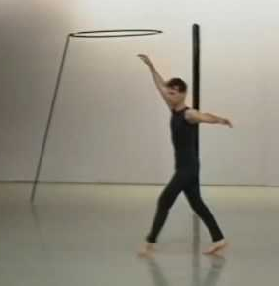
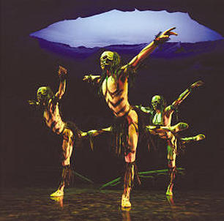

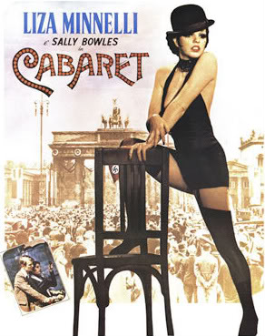
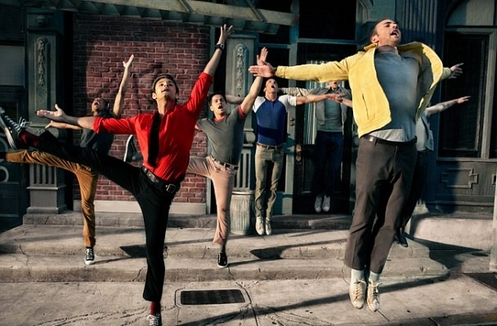

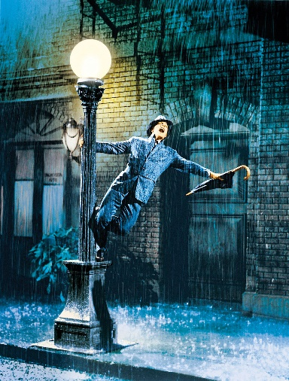
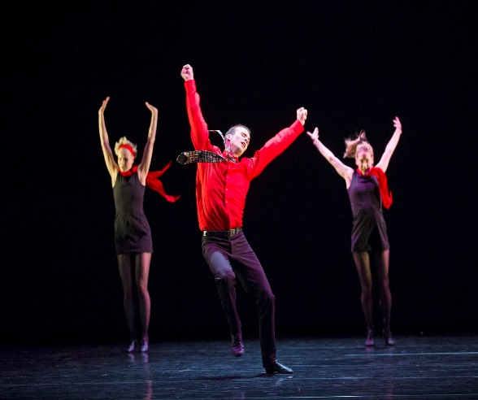

AQA A Level Dance – Assessment Criteria

Performance
Demonstration of Physical/Technical Skills | Demonstration of spatial elements and spatial awareness. | Demonstration of dynamics elements. | Interpretative/ performance skills (timing and musicality) | Interpretative/  performance  skills (focus,  projection,  emphasis and  expression)
A Level: Solo (linked to practitioner) and performance within a quartet marked out of 20
Exceptional, Highly Articulate, Proficient, Adequate or nothing worth credit.

Selection of the movement components | Manipulation of the movement components | Structuring of movement material | Use of other constituent features e.g. aural and physical setting | Use of other constituent features: Dancers
A Level: Group Choreography marked out of 40
Exceptional, Highly Refined, Proficient, Adequate or nothing worth credit.
Choreography

